

**Market Survey and Viability Assessment for Sustainable Agriculture Initiatives in Rural Communities**

Submitted by : Aryan Dhasmana

23BCB10081 (BE CSE CSBS)

CBS121 - B

Email : 23bcb10081@cuchd.in

**Table of Contents**

**Introduction ………………………………………………………… 3**

**Objective ……………………………………………………………. 3**

**Daily** **Observations ………………………………………………….. 4**

* Day 1: The Initial Impression- Exploring the market
* Day 2: Broadening the Horizons – To the village
* Day 3: A Taste of Local Ingenuity - Identifying local Businesses
* Day 4: From Farms to Folk Remedies – Exploring local Businesses
* Day 5: Embracing Community Initiatives

**Existing Market Analysis …………………………………………. 9**

* Agricultural Production
* Migration
* Local Infrastructure

**Viable Business Ideas………………………………………………. 9**

* Concept
* Viability Assessment
* Possible Challenges
* Socio Economic Impact

**Challenges Faced ……………………………………………………. 9**

**Recommendations ………………………………………………….. 10**

**Conclusion ………….………………………………………………. 11**

**Appendices …………………………………………………………. 12**

**1. Introduction**

Jaiheri Village, in the beautiful Garhwal Himalayas, is known for its farming, especially for growing fruits used to make jams and juices. This report looks at the current market, the best business ideas, the problems, and the effects of new projects.

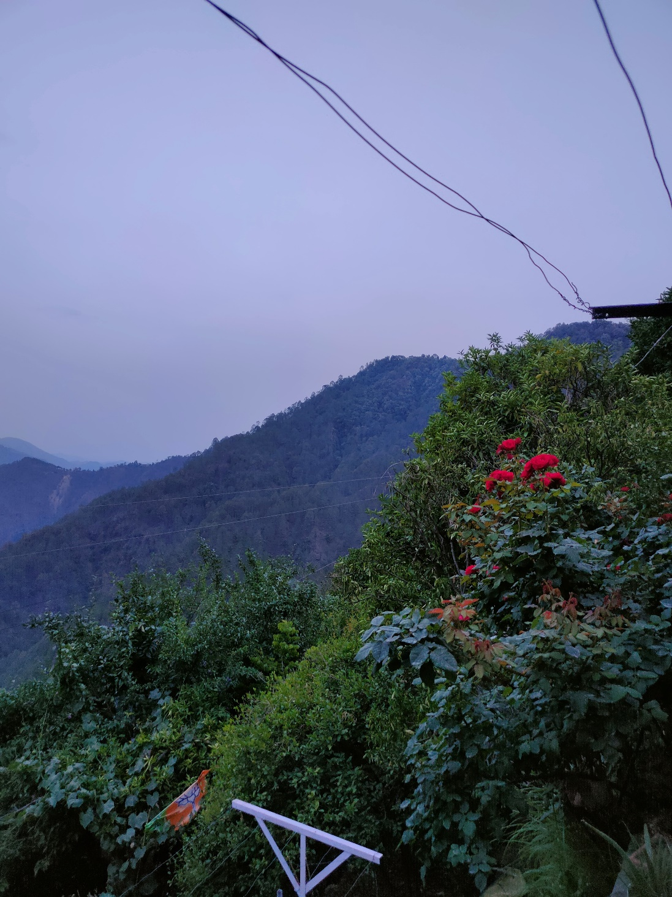

*Fig : Serene beauty of the village*

Jaiheri is a small village in the Jaiharikhal Block of Pauri Garhwal District in Uttarakhand State, India. It's south of the district headquarters in Pauri, not far from Jaiharikhal, and quite a distance from the state capital, Dehradun.

The village has 1,666 people, in 398 families. There's an equal number of males and females, so the sex ratio is 1000, which is higher than the Uttarakhand average of 963. But there's a lower number of young children, at 147, with a lower child-sex ratio of 861 compared to the state average of 890.

Jaiheri's picture of the people living there shows that there's a good labor force but also a need to focus on young people. Equal numbers of males and females suggest a strong community. But there may be social problems because of the low number of young girls.

In recent times, Jaiheri has had some big problems, like 16% of people leaving the village — the highest in the state. This caused fewer people working in farming and left many fields unused. But the village is still busy making fruit-based products.

**2. Objective**

The purpose of this report is to conduct a thorough analysis of the current market conditions in Jaiheri Village and identify potential business opportunities that can make the most of local resources and strengths. The report aims to:

* Assess the Current Market Conditions: This involves evaluating the existing market for agricultural products, particularly fruit jams and juices, including market reach, consumer base, and job opportunities.
* Analyze Local Infrastructure: This means reviewing the village's infrastructure, including the facilities and services in the village centre, and how they impact local businesses.
* Evaluate Migration Impact: Understanding how high rates of migration affect the agricultural sector and the overall economic stability of Jaiheri.
* Identify Viable Business Opportunities: Proposing potential business ventures that align with local resources and strengths, focusing on sustainability and economic diversification.
* Assess Viability and Challenges: Evaluating the feasibility of proposed business ideas, including potential challenges in implementation and strategies to overcome them.
* Assess Socio-Economic Impacts: Analysing the potential socio-economic impacts of the proposed business opportunities on the local economy and community well-being.
* Provide Recommendations: Offering strategic recommendations to support the development and sustainability of identified business opportunities, with the aim of enhancing economic resilience and community development in Jaiheri.

By achieving these objectives, the report seeks to promote economic revitalization in Jaiheri Village, reduce the adverse effects of migration, and encourage sustainable and inclusive growth.

**3. Daily** **Observations**

**Day 1: Initial Impressions**

**Primary Activity:** Arriving in the village, exploring shops (general store, vegetable stall, newspaper vendor, bank).

**Key Observations:**

* The village is small with a simple layout centered around a dusty crossroads.
* Warm reception from shopkeepers and locals, fostering a sense of community.
* Breathtaking natural beauty with majestic mountains in the distance.

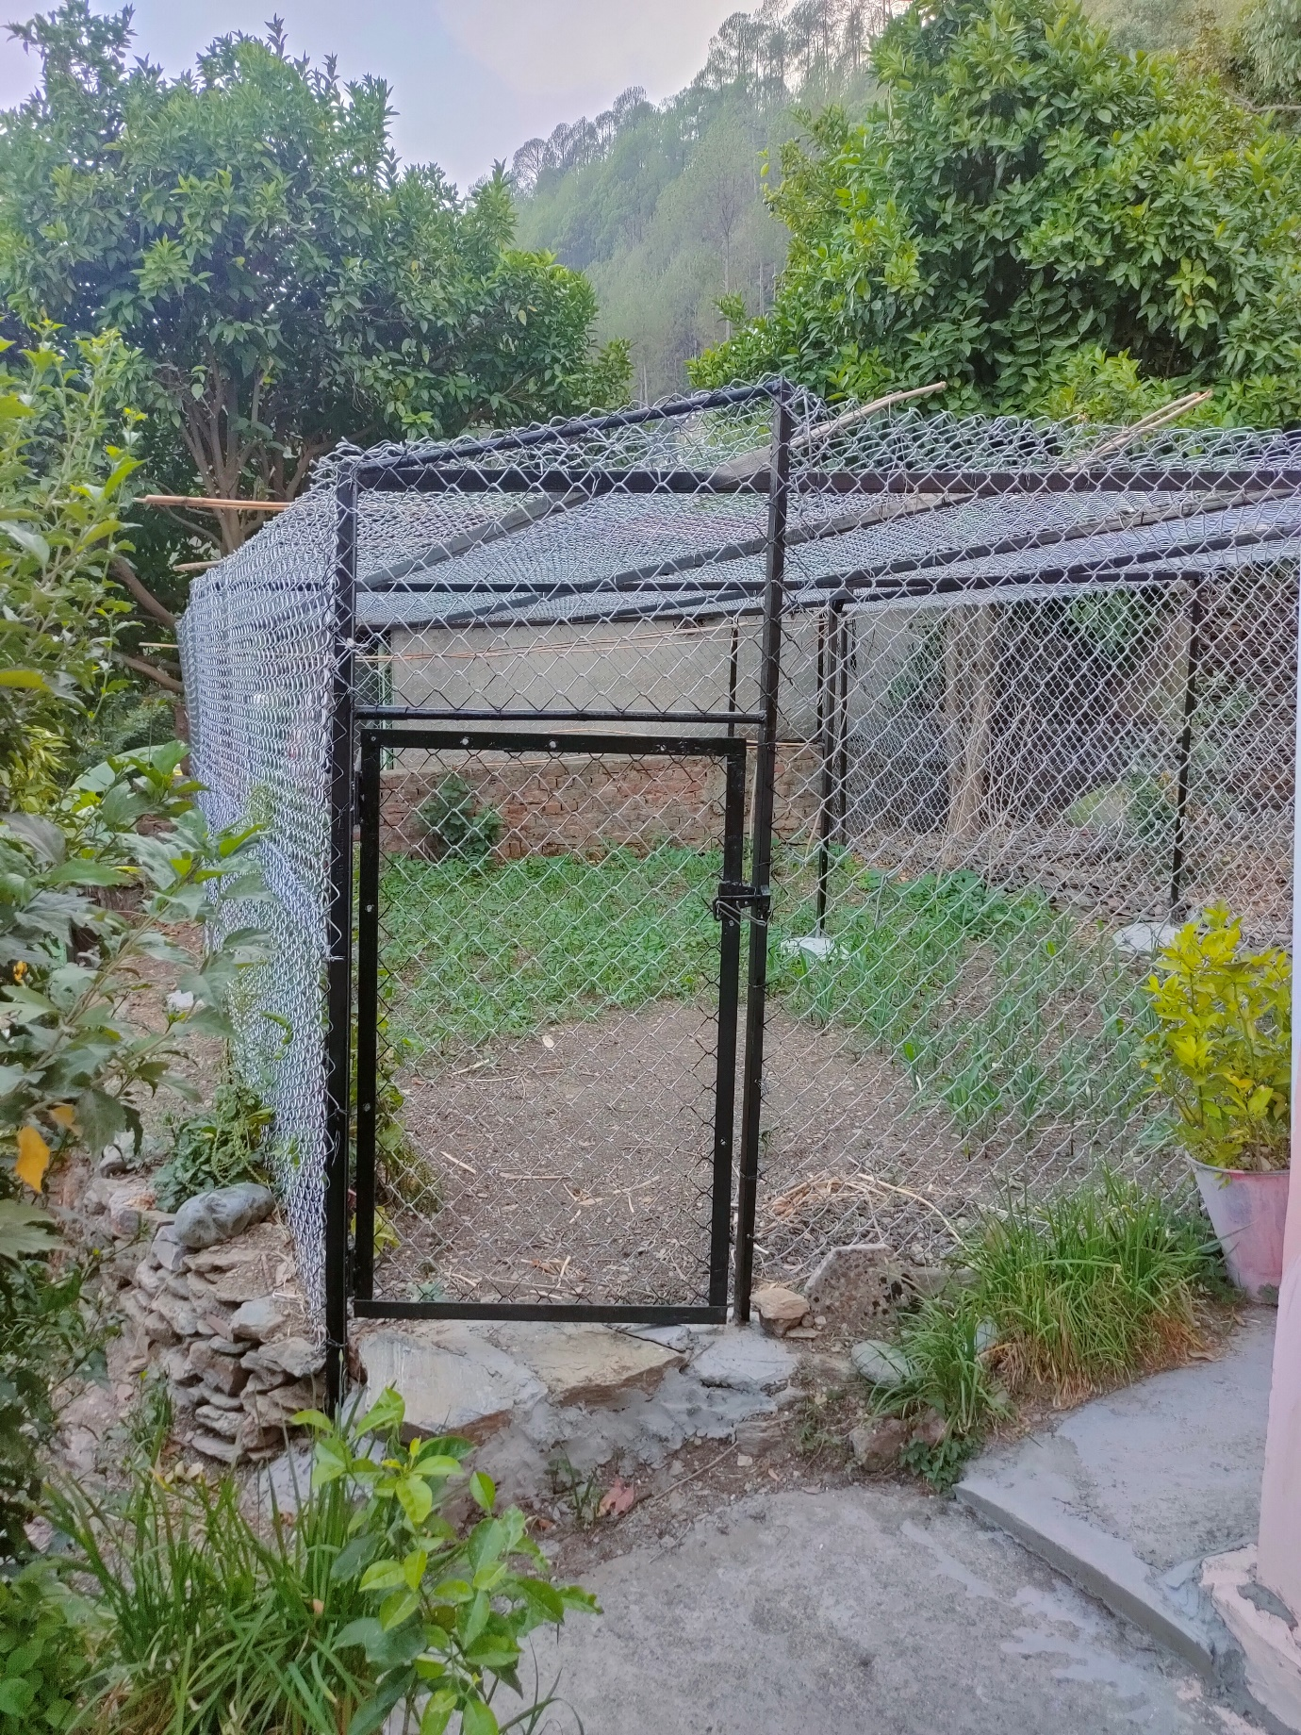

*Fig : Cage like structure being used to protect crops*

**Day 2: Broadening the Horizons**

**Primary Activity:** Walking through the village, observing daily life.

**Key Observations:**

* + - Slower pace of life compared to urban areas, characterized by peaceful surroundings and natural sounds.
    - Local challenges highlighted, such as transportation difficulties affecting supply chains and economic activities.
    - Strong community bonds evident through interactions with locals, who share stories of resilience amid hardships.

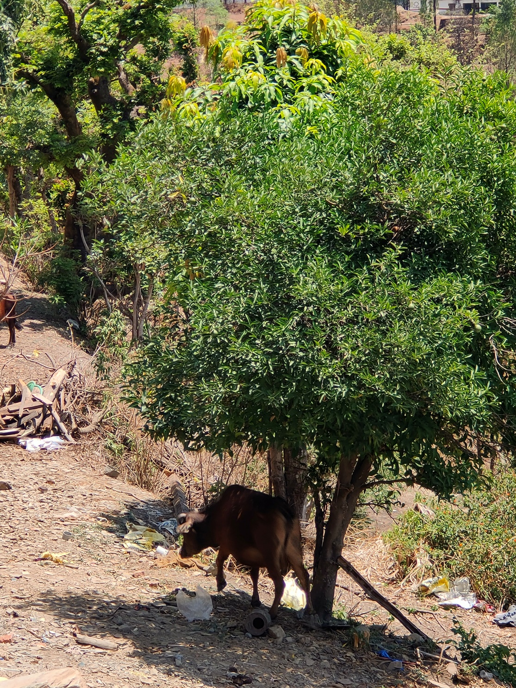

*Fig : Local cows Roaming around*

**Day 3: A Taste of Local Ingenuity**

**Primary Activity:** Exploring local horticultural initiatives and small-scale businesses.

**Key Observations:**

* + - Vibrant local economy centred around agriculture and homemade products like jams and pickles.
    - Entrepreneurial spirit among villagers utilizing local resources for economic sustainability.
    - Potential for further development and support of local enterprises to enhance community livelihoods.

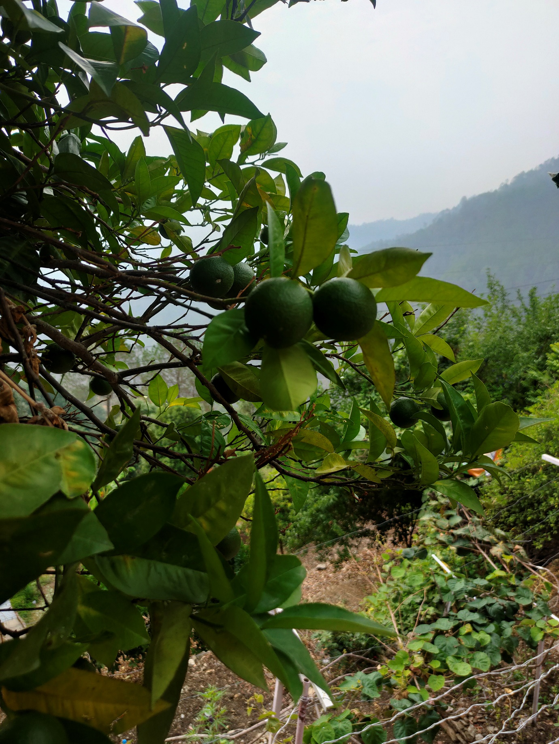

*Fig : A local citric fruit known as “Malta”used for making squash*

**Day 4: From Farms to Folk Remedies**

**Primary Activity:** Engaging with local farmers and learning about agricultural practices.

**Key Observations:**

* + - Insights into farming challenges including wildlife impacts on crops.
    - Rich traditional knowledge of local fruits and medicinal herbs, passed down through generations.
    - Appreciation for the dual role of agriculture in food production and cultural preservation.

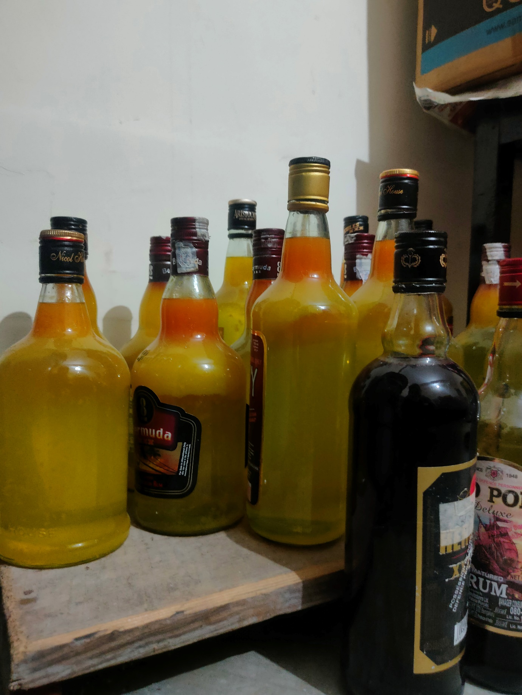

*Fig : Juices made from locally grown produce stored in recycled glass bottles*

**Day 5: Embracing Community Initiatives**

**Primary Activity:** A meet with Village Pradhan

**Key Observations:**

* Initiative to address village challenges collaboratively, such as improving transportation logistics and diversifying income streams.
* Recognition of existing community strengths in entrepreneurship and traditional knowledge.
* Commitment to sustainable development and resilience in the face of external challenges.

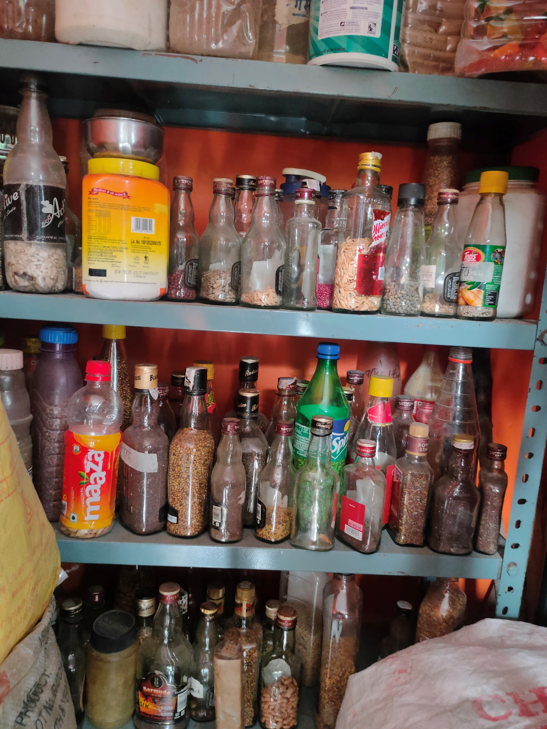

*Fig : Different kinds of Herbs with medicinal properties demonstrating indigenous wisdom*

**4. Existing Market Analysis**

**Agricultural Products:**

**Fruit Jams and Juices:** Jaiheri's fertile land supports the cultivation of various fruits such as apples, plums, and peaches. These fruits are processed into high-quality jams and juices known for their organic nature and traditional preparation methods.

**Market Reach:** Currently, the distribution of these products is limited. Most sales occur within local markets, where villagers and nearby residents purchase these goods. Products are sporadically supplied to nearby towns, but this is not a significant part of the market strategy.

**Consumer Base:** The primary consumers are local residents who prefer organic and locally sourced products. There is also a small but growing market among tourists who visit Jaiheri for its natural beauty and authentic local products.

**Employment Scenario:**

**Agricultural Sector:** The majority of employment in Jaiheri revolves around agriculture, specifically the cultivation and processing of fruits, providing the primary source of income for most families.

**Limited Diversification:** There are few alternative employment opportunities in Jaiheri, leading to a high dependency on the agricultural cycle. Income levels fluctuate with the seasons, impacting financial stability for many households.

**Local Infrastructure:**

**Village Center:** The village center, located at the top of the hill, serves as the main commercial hub with a small market and a few grocery shops catering to the basic needs of the villagers. It provides essential goods and services for daily living.

**Services:** Jaiheri has a post office and a branch of a modern bank, offering essential financial and communication services to the residents. However, the overall infrastructure remains underdeveloped, potentially hindering the growth of new business ventures.

**Migration Impact:**

**Population Decline:** Over the past decade, Jaiheri has experienced a significant population decline due to migration, driven by young residents seeking better educational and employment opportunities in urban areas.

**Agricultural Decline:** The migration has resulted in many agricultural fields lying empty, as the workforce available for farming has decreased. This decline not only affects the local economy but also threatens the sustainability of traditional farming practices and local food production.

**Summarised Analysis:**

The agricultural sector in Jaiheri, while still a cornerstone of the village's economy, faces significant challenges. The high rate of migration has reduced the workforce, making it difficult to maintain and expand agricultural activities. This decline impacts overall productivity and economic stability.

The limited market reach of Jaiheri’s agricultural products also constrains growth. Expanding distribution networks and marketing efforts could enhance market reach, providing new revenue streams and reducing dependency on local consumers.

The village center, despite being the commercial hub, lacks the infrastructure needed to support large-scale business operations. Further development is required to support new business ventures, especially those aiming to cater to tourists.

Addressing the migration issue is critical for Jaiheri’s future. Creating new economic opportunities within the village, such as through eco-tourism and agri-tourism, could help retain the population and attract former residents back. These initiatives could diversify the economy, provide stable income sources, and reduce the community’s reliance on agriculture alone.

Overall, the existing market analysis highlights the need for strategic interventions to revitalize Jaiheri’s agricultural sector, improve infrastructure, and develop new business opportunities to counteract the effects of migration and enhance economic resilience.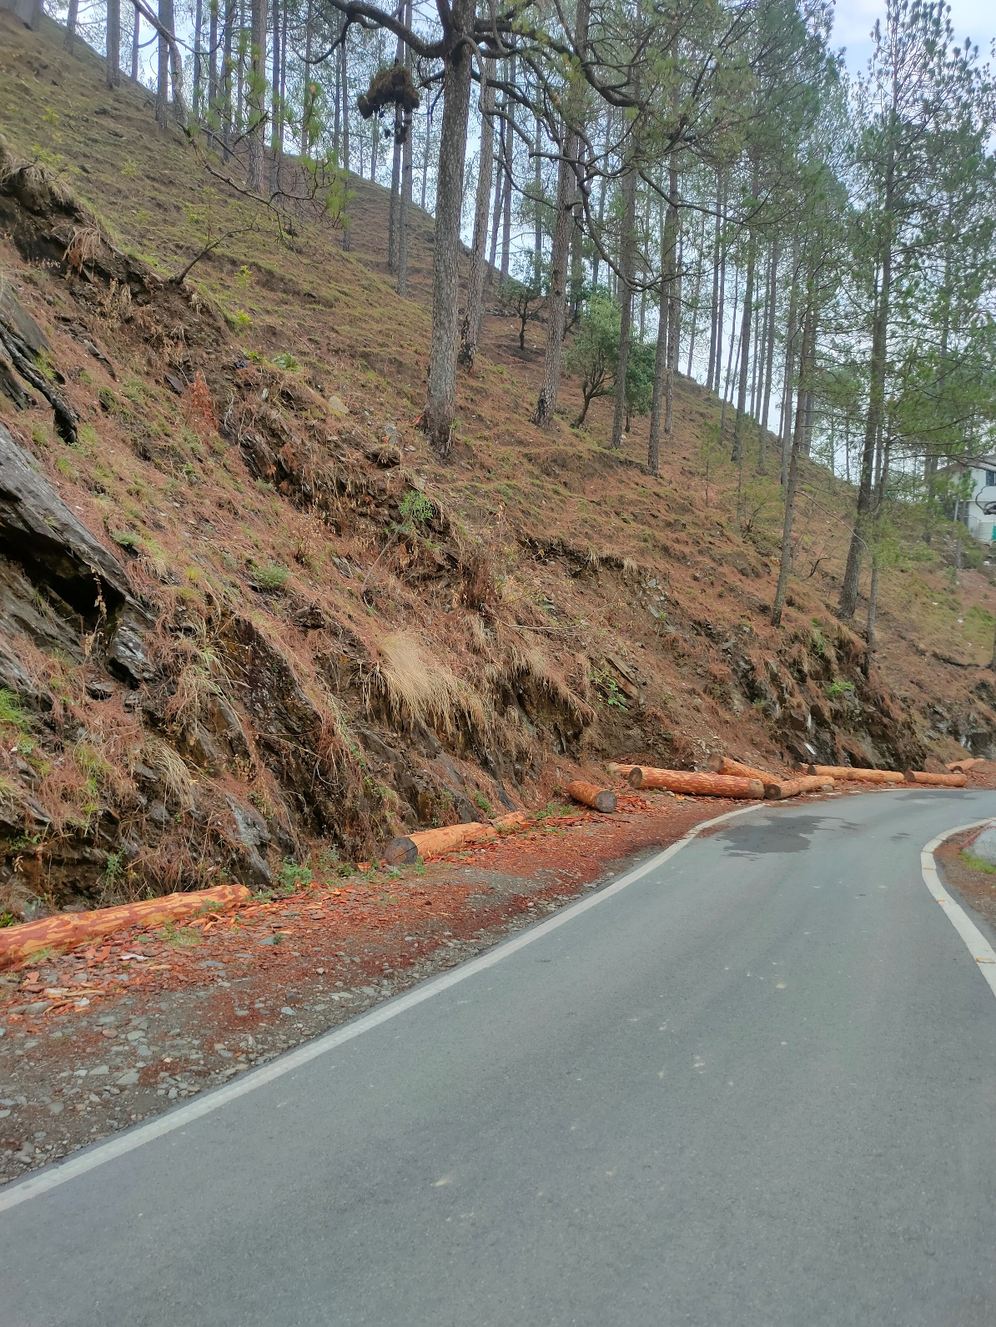

*Fig : Narrow winding roads*

**5. Viable Business Idea: Eco-Tourism and Agri-Tourism**

**Business Concept:**

**Eco-Tourism:** We will develop packages that showcase Jaiheri's natural beauty, hiking trails, and local culture.

**Activities:** Our offerings will include guided hikes, nature walks, and tours of fruit orchards and processing facilities.

**Accommodation:** Visitors can stay in eco-lodges or experience farm stays promoting sustainable living and cultural immersion.

**Agri-Tourism:** We will showcase agricultural practices and fruit processing techniques through hands-on learning experiences.

**Workshops:** Visitors can participate in jam and juice-making sessions using local fruits during our hands-on workshops.

**Culinary Experiences:** We will offer cooking classes featuring traditional recipes using village produce.

Moreover creating an online platform or service that facilitates the sale of locally produced goods, particularly agricultural products, through established e-commerce marketplaces like Amazon and Flipkart. This would enable rural communities to access a wider audience and capitalize on the growing trend of online shopping.

**Viability Assessment:**

**Natural Appeal:** Jaiheri's scenic landscapes and traditional practices appeal to eco-conscious tourists.

**Local Expertise:** The village has established knowledge in fruit cultivation, which enhances authenticity and visitor engagement.

**Market Demand:** There is a growing interest in sustainable travel and cultural experiences, supporting the viability of our ventures.

**Possible Challenges:**

**Infrastructure:** Limited transport and accommodation options may hinder accessibility and visitor comfort.

**Seasonality:** Fluctuations in tourism and agricultural activities could impact revenue streams and operational stability.

**Marketing:** Effective promotion is crucial to attract eco-tourists and differentiate from competitors.

**Community Engagement:** Ensuring local support and participation is critical for sustainable development.

**Migration Impact:** Addressing the effects of population decline and revitalizing agricultural activity are essential.

**Socio-Economic Impact:**

**Employment Generation:** We aim to diversify job opportunities beyond agriculture, particularly in tourism-related services.

Income Enhancement: Our initiatives will provide supplementary income for farmers and artisans through tourism and product sales.

**Cultural Preservation:** We will promote local heritage, preserve agricultural traditions, and culinary practices.

**Environmental Conservation:** Our efforts will encourage sustainable practices, contributing to ecosystem preservation and responsible tourism.

**Population Retention:** Creating new opportunities may help curb migration trends and attract former residents back to the village.

**6. Recommendations**

Based on the analysis and assessment conducted, the following recommendations are proposed to enhance the success and sustainability of eco-tourism and agri-tourism initiatives in Jaiheri Village:

* **Infrastructure Development**: Invest in improving local transportation and accommodation facilities to enhance visitor experience and accessibility.
* **Marketing Strategy**: Implement a robust marketing plan focusing on digital platforms, eco-tourism associations, and niche travel agencies to attract target markets.
* **Community Involvement**: Foster partnerships with local residents, farmers, and artisans to ensure mutual benefits and support for tourism initiatives.
* **Seasonal Planning**: Develop diversified activities and events throughout the year to mitigate the impact of seasonal fluctuations on business operations.
* **Revitalize Agriculture**: Implement programs to revitalize abandoned fields and encourage agricultural activity, potentially attracting younger residents to return.

**7. Conclusion**

In conclusion, the eco-tourism and agri-tourism ventures in Jaiheri Village hold substantial potential for economic diversification and sustainable development. Addressing challenges such as infrastructure limitations, seasonal variability, and the impacts of migration is essential for long-term success. By leveraging local strengths, promoting cultural preservation, and adopting environmentally responsible practices, these initiatives can contribute positively to the local economy while offering enriching experiences for visitors.

**8. Appendices**

**Note**: The QR code provided below links to the GitHub repository containing all the data presented in the report.

[](https://github.com/aryan-0102/projects/tree/main/Social_Internship)

This repository serves as a comprehensive resource for further exploration and analysis of the findings, recommendations, and additional data collected during the investigation. Feel free to access the repository for detailed information and to engage with the content presented in this report.